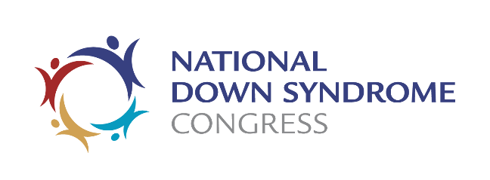
National Down Syndrome Congress
Board Nominee Information Form

Name: Click here to enter text.

Address: Click here to enter text.

Home Phone: Click here to enter text.
Work: Click here to enter text.
Cell: Click here to enter text.
Fax: Click here to enter text.

E-Mail: Click here to enter text.

1. Are you a current member of the NDSC? YES ☐ NO ☐
If so, how long have you been a member? Click here to enter text.

2. Have you ever served on an NDSC Committee? YES ☐ NO ☐
If so, please indicate which committee(s), years and activities. Click here to enter text.

3. Are you a family member of a person with Down syndrome? YES ☐ NO ☐
If so, indicate the person’s age and relationship to you. Click here to enter text.

4. Are you a professional in the field of developmental disabilities? YES ☐ NO ☐
If so, please describe the area of specialty and/or attach a resume. Click here to enter text.

5. Have you ever attended an NDSC Convention? YES ☐ NO ☐
If so, which ones? Click here to enter text.

6. Have you ever attended an NDSC Board meeting? YES ☐ NO ☐
If so, please give date & place. Click here to enter text.

7. Have you served as a member of the Board of Directors of any local/state/regional non-profit organizations serving people with Down syndrome or developmental disabilities?
If so, please describe your experience. Click here to enter text.

8. Please describe any other non-profit experience. Click here to enter text.

9. Are you a member of a local Down syndrome parent organization? YES ☐ NO ☐
If so, please include the name of the organization and describe your involvement. Click here to enter text.

10. Please provide a written statement that includes the following information
a. Biographical data relevant to potential participation on the NDSC Board of Directors (You may choose to attach a resume.)Click here to enter text.
b. A personal statement describing your motivation and interest in serving as an NDSC Board member (in general, as well as indicating specific interest areas) Click here to enter text.
- A description of personal qualities or qualifications that would assist you in your duties as a Board member. Click here to enter text.

11. Please submit two letters of reference from individuals who can comment on your experience with not-for-profit Boards of Directors and/or on qualities that make you an appropriate candidate for service on a national Board. You may attach these to your application, or the writers may send them directly to National Down Syndrome Congress, Attn: Marilyn Tolbert, Nominating Committee, 30 Mansell Court, Suite 108, Roswell, GA 30076; info@ndsccenter.org

I have read the Nominating Process Information form and understand the conditions under which I agree to have my name placed into consideration with the Nominating Committee. I realize that all expenses of my Board membership are my personal responsibility. I also agree, if elected or appointed, to attend all scheduled Board meetings to the best of my ability.

Name (please print): Click here to enter text.

Date: Click here to enter a date.

Signature: _________________________________________________________________

